Week 4_ 4. spring-rest-handson
HandsOn_1. RESTful Web Service resource naming guidelines
CountryController.java
package com.example.country.controller;

import com.example.country.model.Country;
import com.example.country.service.CountryService;
import org.springframework.beans.factory.annotation.Autowired;
import org.springframework.web.bind.annotation.*;

import java.util.List;

@RestController
@RequestMapping("/countries") // Base URL defined once here
public class CountryController {

@Autowired
private CountryService countryService;

@GetMapping
public List<Country> getAllCountries() {
return countryService.getAllCountries();
}

@GetMapping("/{code}")
public Country getCountryByCode(@PathVariable String code) {
return countryService.getCountryByCode(code);
}

@PostMapping
public Country createCountry(@RequestBody Country country) {
return countryService.createCountry(country);
}

@PutMapping
public Country updateCountry(@RequestBody Country country) {
return countryService.updateCountry(country);
}

@DeleteMapping("/{code}")
public void deleteCountry(@PathVariable String code) {
countryService.deleteCountry(code);
}
}
Country.java
package com.example.country.model;

public class Country {
private String code;
private String name;

public Country() {}

public Country(String code, String name) {
this.code = code;
this.name = name;
}

public String getCode() {
return code;
}

public void setCode(String code) {
this.code = code;
}

public String getName() {
return name;
}

public void setName(String name) {
this.name = name;
}
}
CountryService.java
package com.example.country.service;

import com.example.country.model.Country;
import org.springframework.stereotype.Service;

import java.util.ArrayList;
import java.util.List;

@Service
public class CountryService {

private static final List<Country> countryList = new ArrayList<>();

static {
countryList.add(new Country("IN", "India"));
countryList.add(new Country("US", "United States"));
countryList.add(new Country("UK", "United Kingdom"));
}

public List<Country> getAllCountries() {
return countryList;
}

public Country getCountryByCode(String code) {
return countryList.stream()
.filter(c -> c.getCode().equalsIgnoreCase(code))
.findFirst()
.orElse(null);
}

public Country createCountry(Country country) {
countryList.add(country);
return country;
}

public Country updateCountry(Country updatedCountry) {
for (int i = 0; i < countryList.size(); i++) {
Country c = countryList.get(i);
if (c.getCode().equalsIgnoreCase(updatedCountry.getCode())) {
countryList.set(i, updatedCountry);
return updatedCountry;
}
}
return null;
}

public void deleteCountry(String code) {
countryList.removeIf(c -> c.getCode().equalsIgnoreCase(code));
}
}
CountryServiceApplication.java
package com.example.country;

import org.springframework.boot.SpringApplication;
import org.springframework.boot.autoconfigure.SpringBootApplication;

@SpringBootApplication
public class CountryServiceApplication {
public static void main(String[] args) {
SpringApplication.run(CountryServiceApplication.class, args);
}
}
application.properties
spring.application.name=code
server.port=8088

CodeApplicationTests.java
package com.example.country;

import org.junit.jupiter.api.Test;
import org.springframework.boot.test.context.SpringBootTest;

@SpringBootTest
class CodeApplicationTests {

@Test
void contextLoads() {
}

}
OUTPUT
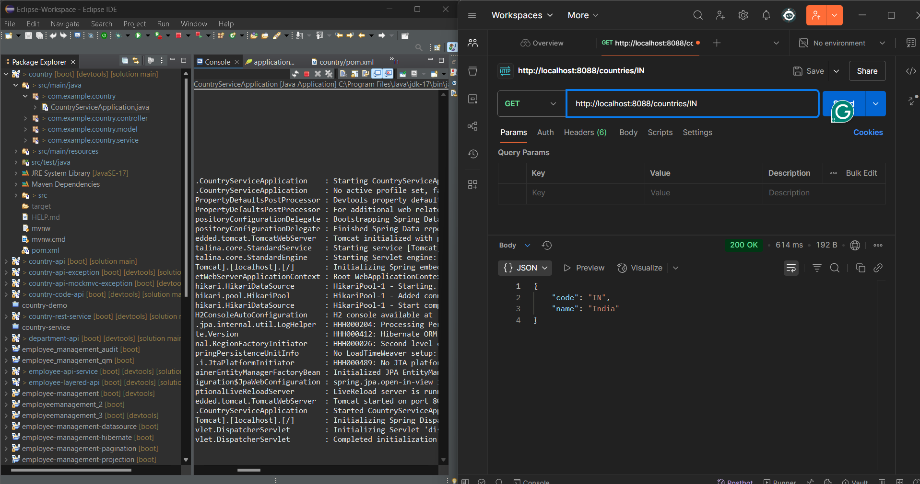

HandsOn_2. Create RESTful Web Service to handle POST request of Country
CountryController.java
package com.example.country_2.controller;

import org.slf4j.Logger;
import org.slf4j.LoggerFactory;
import org.springframework.web.bind.annotation.*;

@RestController
@RequestMapping("/countries")
public class CountryController {

private static final Logger logger = LoggerFactory.getLogger(CountryController.class);

@PostMapping
public void addCountry() {
logger.info("Start");
}
}
CountryApiApplication.java
package com.example.country_2;

import org.springframework.boot.SpringApplication;
import org.springframework.boot.autoconfigure.SpringBootApplication;

@SpringBootApplication
public class CountryApiApplication {

public static void main(String[] args) {
SpringApplication.run(CountryApiApplication.class, args);
}
}
application.properties
spring.application.name=code
server.port=8088
CodeApplicationTests.java
package com.example.country_2;
import org.junit.jupiter.api.Test;
import org.springframework.boot.test.context.SpringBootTest;
@SpringBootTest
class CodeApplicationTests {
@Test
void contextLoads() {
}
}
OUTPUT
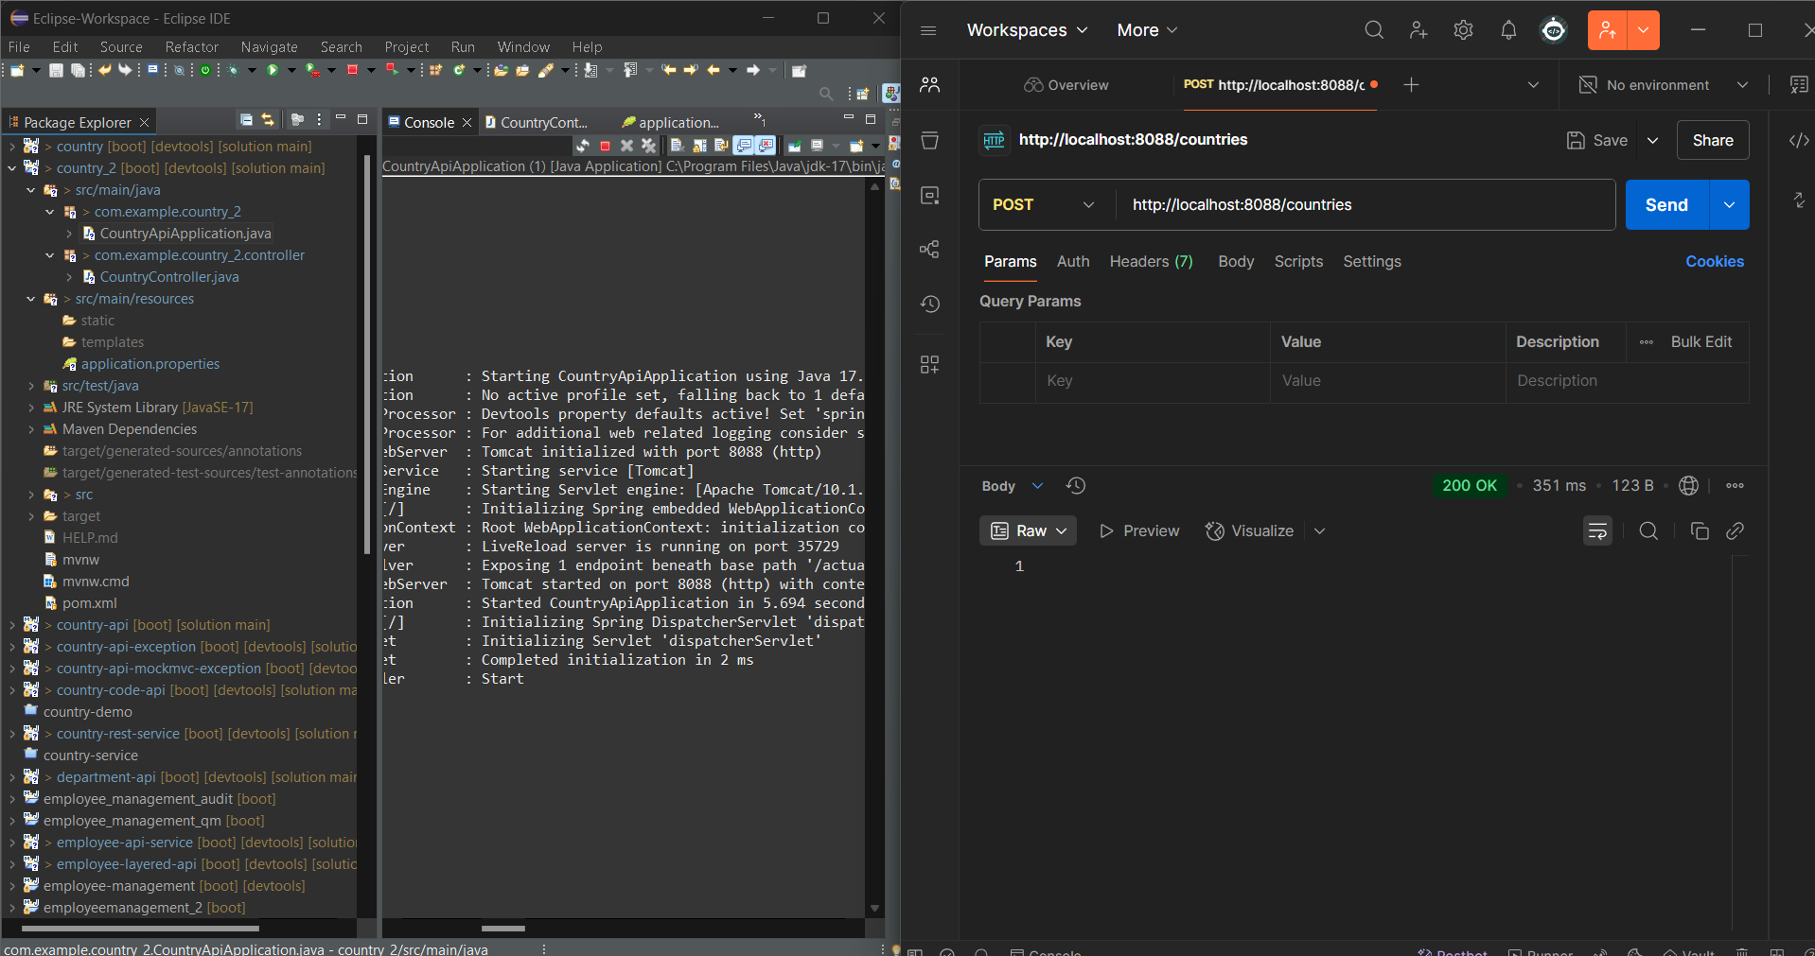
HandsOn_3. Read country data as a bean in RESTful Web Service
CountryController.java
package com.example.countrybean.controller;

import com.example.countrybean.model.Country;
import org.slf4j.Logger;
import org.slf4j.LoggerFactory;
import org.springframework.web.bind.annotation.*;

@RestController
@RequestMapping("/countries")
public class CountryController {

Logger logger = LoggerFactory.getLogger(CountryController.class);

@PostMapping
public Country addCountry(@RequestBody Country country) {
logger.info("Country Code: {}", country.getCode());
logger.info("Country Name: {}", country.getName());
return country;
}
}
Country.java
package com.example.countrybean.model;

public class Country {
private String code;
private String name;

// Getters & Setters
public String getCode() {
return code;
}

public void setCode(String code) {
this.code = code;
}

public String getName() {
return name;
}

public void setName(String name) {
this.name = name;
}
}
CountryBeanApplication.java
package com.example.countrybean;

import org.springframework.boot.SpringApplication;
import org.springframework.boot.autoconfigure.SpringBootApplication;

@SpringBootApplication
public class CountryBeanApplication {
public static void main(String[] args) {
SpringApplication.run(CountryBeanApplication.class, args);
}
}
application.properties
spring.application.name=code
CodeApplicationTests.java
package com.example.countrybean;
import org.junit.jupiter.api.Test;
import org.springframework.boot.test.context.SpringBootTest;
@SpringBootTest
class CodeApplicationTests {
@Test
void contextLoads() {
}
}
OUTPUT
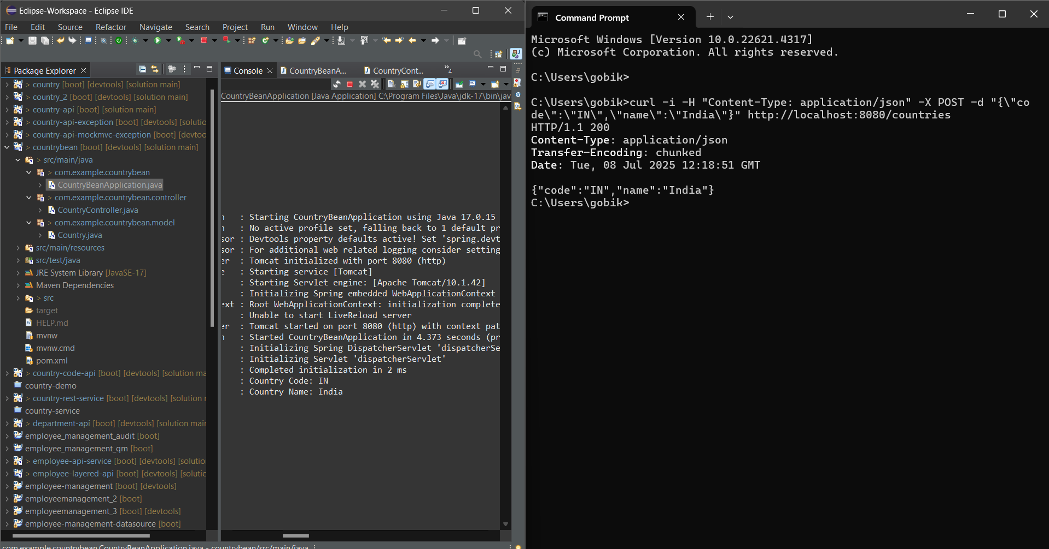

HandsOn_4. Validating country code
CountryController.java
package com.example.CountryValidationManual.controller;

import com.example.CountryValidationManual.model.Country;
import org.slf4j.Logger;
import org.slf4j.LoggerFactory;
import org.springframework.http.HttpStatus;
import org.springframework.web.bind.annotation.*;
import org.springframework.web.server.ResponseStatusException;

import jakarta.validation.Validation;
import jakarta.validation.Validator;
import jakarta.validation.ValidatorFactory;
import jakarta.validation.ConstraintViolation;

import java.util.*;

@RestController
public class CountryController {

private static final Logger LOGGER = LoggerFactory.getLogger(CountryController.class);

@PostMapping("/countries")
public Country addCountry(@RequestBody Country country) {
LOGGER.info("Inside addCountry");

// Step 1: Build validator
ValidatorFactory factory = Validation.buildDefaultValidatorFactory();
Validator validator = factory.getValidator();

// Step 2: Validate Country
Set<ConstraintViolation<Country>> violations = validator.validate(country);
List<String> errors = new ArrayList<>();

for (ConstraintViolation<Country> violation : violations) {
errors.add(violation.getMessage());
}

// Step 3: If any error, return 400
if (!errors.isEmpty()) {
throw new ResponseStatusException(HttpStatus.BAD_REQUEST, errors.toString());
}

return country; // Return only if valid
}
}
Country.java
package com.example.CountryValidationManual.model;

import jakarta.validation.constraints.NotNull;
import jakarta.validation.constraints.Size;

public class Country {

@NotNull
@Size(min = 2, max = 2, message = "Country code should be 2 characters")
private String code;

@NotNull
private String name;

// Getters and setters
public String getCode() {
return code;
}
public void setCode(String code) {
this.code = code;
}
public String getName() {
return name;
}
public void setName(String name) {
this.name = name;
}
}
CountryValidationManualApplication.java
package com.example.CountryValidationManual;
import org.springframework.boot.SpringApplication;
import org.springframework.boot.autoconfigure.SpringBootApplication;
@SpringBootApplication
public class CountryValidationManualApplication {
public static void main(String[] args) {
SpringApplication.run(CountryValidationManualApplication.class, args);
}
}
application.properties
spring.application.name=CountryValidationManual
server.port=8088
CountryValidationManualApplicationTests.java
package com.example.CountryValidationManual;
import org.junit.jupiter.api.Test;
import org.springframework.boot.test.context.SpringBootTest;
@SpringBootTest
class CountryValidationManualApplicationTests {
@Test
void contextLoads() {
}
}
OUTPUT
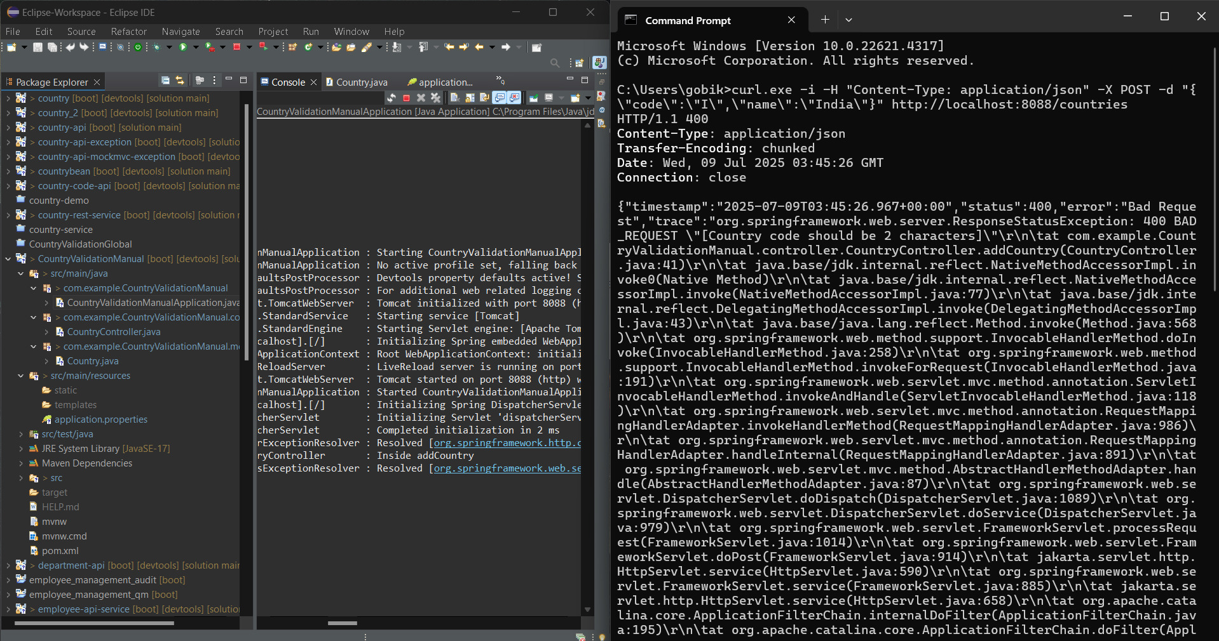

HandsOn_5. Include global exception handler for validation errors
CountryController.java
package com.example.CountryValidationGlobal.controller;

import com.example.CountryValidationGlobal.model.Country;
import org.slf4j.Logger;
import org.slf4j.LoggerFactory;
import org.springframework.web.bind.annotation.*;

import javax.validation.Valid;

@RestController
@RequestMapping("/countries")
public class CountryController {

private static final Logger LOGGER = LoggerFactory.getLogger(CountryController.class);

@PostMapping
public Country addCountry(@RequestBody @Valid Country country) {
LOGGER.info("Inside addCountry");
return country;
}
}
GlobalExceptionHandler.java
package com.example.CountryValidationGlobal.exception;

import org.slf4j.Logger;
import org.slf4j.LoggerFactory;
import org.springframework.http.*;
import org.springframework.web.bind.MethodArgumentNotValidException;
import org.springframework.web.bind.annotation.ControllerAdvice;
import org.springframework.web.context.request.WebRequest;
import org.springframework.web.servlet.mvc.method.annotation.ResponseEntityExceptionHandler;

import java.util.*;
import java.util.stream.Collectors;

@ControllerAdvice
public class GlobalExceptionHandler extends ResponseEntityExceptionHandler {

private static final Logger LOGGER = LoggerFactory.getLogger(GlobalExceptionHandler.class);

@Override
protected ResponseEntity<Object> handleMethodArgumentNotValid(MethodArgumentNotValidException ex,
HttpHeaders headers,
HttpStatus status,
WebRequest request) {
LOGGER.info("Start - Global Validation Handler");

Map<String, Object> body = new LinkedHashMap<>();
body.put("timestamp", new Date());
body.put("status", status.value());

List<String> errors = ex.getBindingResult()
.getFieldErrors()
.stream()
.map(x -> x.getDefaultMessage())
.collect(Collectors.toList());

body.put("errors", errors);

LOGGER.info("End - Global Validation Handler");

return new ResponseEntity<>(body, headers, status);
}
}
Country.java
package com.example.CountryValidationGlobal.model;

import javax.validation.constraints.NotNull;
import javax.validation.constraints.Size;

public class Country {

@NotNull
@Size(min = 2, max = 2, message = "Country code should be 2 characters")
private String code;

private String name;

// Getters and Setters
public String getCode() {
return code;
}

public void setCode(String code) {
this.code = code;
}

public String getName() {
return name;
}

public void setName(String name) {
this.name = name;
}
}
CountryValidationGlobalApplication.java
package com.example.CountryValidationGlobal;

import org.springframework.boot.SpringApplication;
import org.springframework.boot.autoconfigure.SpringBootApplication;

@SpringBootApplication
public class CountryValidationGlobalApplication {

public static void main(String[] args) {
SpringApplication.run(CountryValidationGlobalApplication.class, args);
}
}
application.properties
spring.application.name=code
server.port=8088

CodeApplicationTests.java
package com.example.CountryValidationGlobal;

import org.junit.jupiter.api.Test;
import org.springframework.boot.test.context.SpringBootTest;

@SpringBootTest
class CodeApplicationTests {

@Test
void contextLoads() {
}

}
OUTPUT
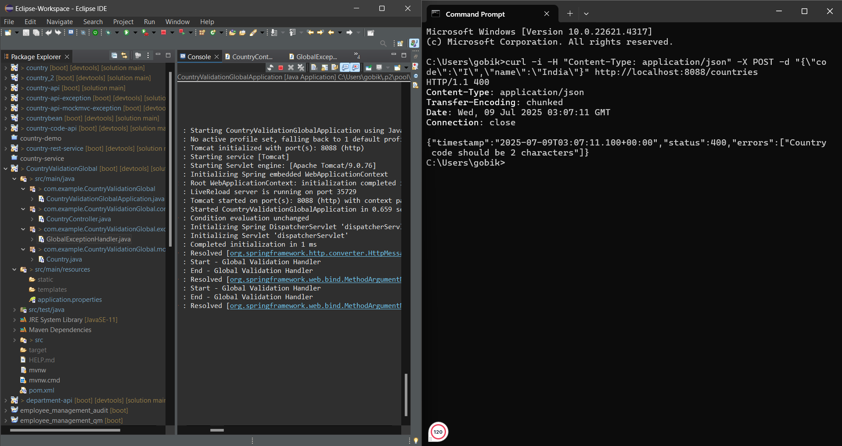

HandsOn_6. Implement REST service for updating an employee
EmployeeController.java
package com.example.EmployeeServiceManual.controller;

import com.example.EmployeeServiceManual.exception.EmployeeNotFoundException;
import com.example.EmployeeServiceManual.model.Employee;
import com.example.EmployeeServiceManual.service.EmployeeService;
import jakarta.validation.Valid;
import org.springframework.beans.factory.annotation.Autowired;
import org.springframework.web.bind.annotation.*;

import java.util.List;

@RestController
@RequestMapping("/employees")
public class EmployeeController {

@Autowired
private EmployeeService service;

@PutMapping
public void updateEmployee(@RequestBody @Valid Employee employee) throws EmployeeNotFoundException {
service.updateEmployee(employee);
}

@GetMapping
public List<Employee> getAllEmployees() {
return service.getAllEmployees();
}

@PostMapping
public void addEmployee(@RequestBody @Valid Employee employee) {
service.addEmployee(employee);
}
}
EmployeeDao.java
package com.example.EmployeeServiceManual.dao;

import com.example.EmployeeServiceManual.exception.EmployeeNotFoundException;
import com.example.EmployeeServiceManual.model.Employee;
import org.springframework.stereotype.Repository;

import java.util.ArrayList;
import java.util.List;

@Repository
public class EmployeeDao {

private static List<Employee> EMPLOYEE_LIST = new ArrayList<>();

public void updateEmployee(Employee emp) throws EmployeeNotFoundException {
for (int i = 0; i < EMPLOYEE_LIST.size(); i++) {
if (EMPLOYEE_LIST.get(i).getId().equals(emp.getId())) {
EMPLOYEE_LIST.set(i, emp);
return;
}
}
throw new EmployeeNotFoundException("Employee Not Found");
}

public List<Employee> getAllEmployees() {
return EMPLOYEE_LIST;
}

public void addEmployee(Employee e) {
EMPLOYEE_LIST.add(e);
}
}

EmployeeNotFoundException.java
package com.example.EmployeeServiceManual.exception;

import org.springframework.http.HttpStatus;
import org.springframework.web.bind.annotation.ResponseStatus;

@ResponseStatus(HttpStatus.NOT_FOUND)
public class EmployeeNotFoundException extends Exception {
public EmployeeNotFoundException(String message) {
super(message);
}
}

GlobalExceptionHandler.java
package com.example.EmployeeServiceManual.exception;

import org.springframework.http.HttpHeaders;
import org.springframework.http.HttpStatusCode;
import org.springframework.http.ResponseEntity;
import org.springframework.http.converter.HttpMessageNotReadableException;
import org.springframework.web.bind.MethodArgumentNotValidException;
import org.springframework.web.bind.annotation.ControllerAdvice;
import org.springframework.web.context.request.WebRequest;
import org.springframework.web.servlet.mvc.method.annotation.ResponseEntityExceptionHandler;

import java.util.*;

@ControllerAdvice
public class GlobalExceptionHandler extends ResponseEntityExceptionHandler {

// Handle validation errors
@Override
protected ResponseEntity<Object> handleMethodArgumentNotValid(
MethodArgumentNotValidException ex,
HttpHeaders headers,
HttpStatusCode status,
WebRequest request) {

Map<String, Object> body = new LinkedHashMap<>();
body.put("timestamp", new Date());
body.put("status", status.value());

List<String> errors = new ArrayList<>();
ex.getBindingResult().getFieldErrors().forEach(error -> {
String message = error.getField() + ": " + error.getDefaultMessage();
errors.add(message);
});

body.put("errors", errors);
body.put("message", "Validation failed");
body.put("path", request.getDescription(false).replace("uri=", ""));

return new ResponseEntity<>(body, headers, status);
}

// Handle malformed JSON or invalid input body
@Override
protected ResponseEntity<Object> handleHttpMessageNotReadable(
HttpMessageNotReadableException ex,
HttpHeaders headers,
HttpStatusCode status,
WebRequest request) {

Map<String, Object> body = new LinkedHashMap<>();
body.put("timestamp", new Date());
body.put("status", status.value());
body.put("error", "Malformed JSON or request body");
body.put("message", ex.getMostSpecificCause().getMessage());
body.put("path", request.getDescription(false).replace("uri=", ""));

return new ResponseEntity<>(body, headers, status);
}
}
Department.java
package com.example.EmployeeServiceManual.model;

import jakarta.validation.constraints.*;

public class Department {

@NotNull(message = "Department ID should not be null")
private Integer id;

@NotNull(message = "Department name should not be null")
@NotBlank(message = "Department name should not be blank")
@Size(min = 1, max = 30, message = "Department name should be between 1 and 30 characters")
private String name;

// Getters and Setters
public Integer getId() {
return id;
}
public void setId(Integer id) {
this.id = id;
}

public String getName() {
return name;
}
public void setName(String name) {
this.name = name;
}
}
Employee.java
package com.example.EmployeeServiceManual.model;

import com.fasterxml.jackson.annotation.JsonFormat;
import jakarta.validation.constraints.*;
import java.util.Date;
import java.util.List;

public class Employee {

@NotNull(message = "Employee ID should not be null")
private Integer id;

@NotNull(message = "Name should not be null")
@NotBlank(message = "Name should not be blank")
@Size(min = 1, max = 30, message = "Name should be between 1 and 30 characters")
private String name;

@NotNull(message = "Salary should not be null")
@Min(value = 0, message = "Salary should be zero or above")
private Double salary;

@NotNull(message = "Permanent status should not be null")
private Boolean permanent;

@JsonFormat(shape = JsonFormat.Shape.STRING, pattern = "dd/MM/yyyy")
private Date dateOfBirth;

@NotNull(message = "Department should not be null")
private Department department;

@NotNull(message = "Skills should not be null")
private List<Skill> skills;

// Getters and Setters
public Integer getId() {
return id;
}
public void setId(Integer id) {
this.id = id;
}

public String getName() {
return name;
}
public void setName(String name) {
this.name = name;
}

public Double getSalary() {
return salary;
}
public void setSalary(Double salary) {
this.salary = salary;
}

public Boolean getPermanent() {
return permanent;
}
public void setPermanent(Boolean permanent) {
this.permanent = permanent;
}

public Date getDateOfBirth() {
return dateOfBirth;
}
public void setDateOfBirth(Date dateOfBirth) {
this.dateOfBirth = dateOfBirth;
}

public Department getDepartment() {
return department;
}
public void setDepartment(Department department) {
this.department = department;
}

public List<Skill> getSkills() {
return skills;
}
public void setSkills(List<Skill> skills) {
this.skills = skills;
}
}
Skill.java
package com.example.EmployeeServiceManual.model;

import jakarta.validation.constraints.*;

public class Skill {

@NotNull(message = "Skill ID should not be null")
private Integer id;

@NotNull(message = "Skill name should not be null")
@NotBlank(message = "Skill name should not be blank")
@Size(min = 1, max = 30, message = "Skill name should be between 1 and 30 characters")
private String name;

// Getters and Setters
public Integer getId() {
return id;
}
public void setId(Integer id) {
this.id = id;
}

public String getName() {
return name;
}
public void setName(String name) {
this.name = name;
}
}
EmployeeService.java
package com.example.EmployeeServiceManual.service;
import com.example.EmployeeServiceManual.dao.EmployeeDao;
import com.example.EmployeeServiceManual.exception.EmployeeNotFoundException;
import com.example.EmployeeServiceManual.model.Employee;
import org.springframework.beans.factory.annotation.Autowired;
import org.springframework.stereotype.Service;
import java.util.List;
@Service
public class EmployeeService {
@Autowired
private EmployeeDao dao;
public void updateEmployee(Employee employee) throws EmployeeNotFoundException {
dao.updateEmployee(employee);
}
public List<Employee> getAllEmployees() {
return dao.getAllEmployees();
}
public void addEmployee(Employee e) {
dao.addEmployee(e);
}
}
EmployeeServiceManualApplication.java
package com.example.EmployeeServiceManual;
import org.springframework.boot.SpringApplication;
import org.springframework.boot.autoconfigure.SpringBootApplication;

@SpringBootApplication
public class EmployeeServiceManualApplication {
public static void main(String[] args) {
SpringApplication.run(EmployeeServiceManualApplication.class, args);
}
}
application.properties
spring.application.name=code
server.port=8088
CodeApplicationTests.java
package com.example.EmployeeServiceManual;
import org.junit.jupiter.api.Test;
import org.springframework.boot.test.context.SpringBootTest;
@SpringBootTest
class CodeApplicationTests {
@Test
void contextLoads() {
}
}
OUTPUT
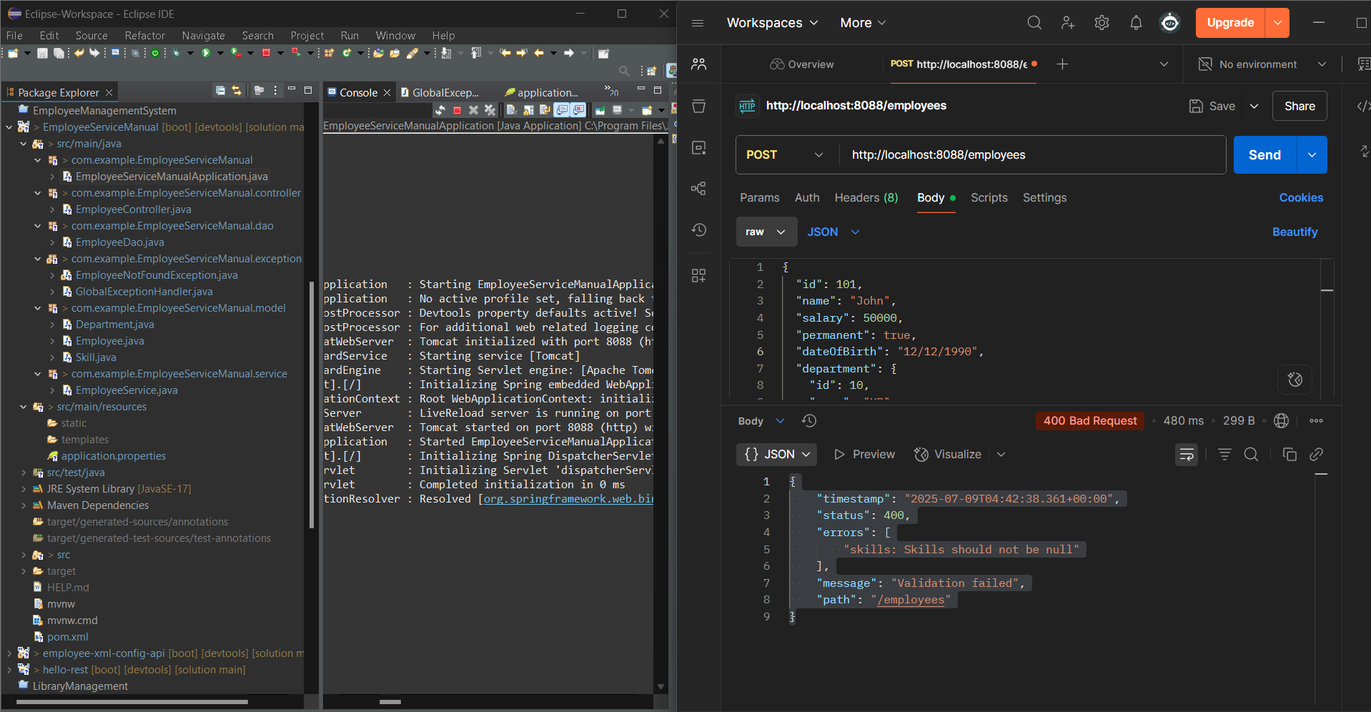

HandsOn_7. Implement REST DELETE Service
EmployeeController.java
package com.example.employeedelete.controller;
import com.example.employeedelete.service.EmployeeService;
import org.springframework.beans.factory.annotation.Autowired;
import org.springframework.http.ResponseEntity;
import org.springframework.web.bind.annotation.*;
@RestController
@RequestMapping("/employees")
public class EmployeeController {
@Autowired
private EmployeeService employeeService;
@DeleteMapping("/{id}")
public ResponseEntity<String> deleteEmployee(@PathVariable int id) {
employeeService.deleteEmployee(id);
return ResponseEntity.ok("Employee with ID " + id + " deleted successfully");
}
}
EmployeeDao.java
package com.example.employeedelete.dao;
import com.example.employeedelete.exception.EmployeeNotFoundException;
import com.example.employeedelete.model.Employee;
import org.springframework.stereotype.Repository;

import java.util.ArrayList;
import java.util.Iterator;
import java.util.List;
@Repository
public class EmployeeDao {
private static List<Employee> employeeList = new ArrayList<>();
static {
employeeList.add(new Employee(1, "Gobika", "IT"));
employeeList.add(new Employee(2, "Rahul", "HR"));
employeeList.add(new Employee(3, "Sneha", "Finance"));
}
public void deleteById(int id) {
Iterator<Employee> iterator = employeeList.iterator();
while (iterator.hasNext()) {
Employee e = iterator.next();
if (e.getId() == id) {
iterator.remove();
return;
}
}
throw new EmployeeNotFoundException("Employee with ID " + id + " not found.");
}
public List<Employee> getAll() {
return employeeList;
}
}
EmployeeNotFoundException.java
package com.example.employeedelete.exception;
public class EmployeeNotFoundException extends RuntimeException {
public EmployeeNotFoundException(String message) {
super(message);
}
}
GlobalExceptionHandler.java
package com.example.employeedelete.exception;
import org.springframework.http.ResponseEntity;
import org.springframework.web.bind.annotation.ExceptionHandler;
import org.springframework.web.bind.annotation.RestControllerAdvice;
@RestControllerAdvice
public class GlobalExceptionHandler {
@ExceptionHandler(EmployeeNotFoundException.class)
public ResponseEntity<String> handleNotFound(EmployeeNotFoundException ex) {
return ResponseEntity.status(404).body(ex.getMessage());
}
}
Employee.java
package com.example.employeedelete.model;
public class Employee {

private int id;
private String name;
private String department;
public Employee() {
}
public Employee(int id, String name, String department) {
this.id = id;
this.name = name;
this.department = department;
}
// Getter for id
public int getId() {
return id;
}
// Setter for id
public void setId(int id) {
this.id = id;
}
// Getter for name
public String getName() {
return name;
}

// Setter for name
public void setName(String name) {
this.name = name;
}
// Getter for department
public String getDepartment() {
return department;
}
// Setter for department
public void setDepartment(String department) {
this.department = department;
}
}
EmployeeService.java
package com.example.employeedelete.service;
import com.example.employeedelete.dao.EmployeeDao;
import org.springframework.beans.factory.annotation.Autowired;
import org.springframework.stereotype.Service;
@Service
public class EmployeeService {
@Autowired
private EmployeeDao employeeDao;
public void deleteEmployee(int id) {
employeeDao.deleteById(id);
}
}
EmployeeDeleteApplication.java
package com.example.employeedelete;
import org.springframework.boot.SpringApplication;
import org.springframework.boot.autoconfigure.SpringBootApplication;
@SpringBootApplication
public class EmployeeDeleteApplication {
public static void main(String[] args) {
SpringApplication.run(EmployeeDeleteApplication.class, args);
}
}
application.properties
spring.application.name=code
server.port=8088
CodeApplicationTests.java
package com.example.employeedelete;
import org.junit.jupiter.api.Test;
import org.springframework.boot.test.context.SpringBootTest;
@SpringBootTest
class CodeApplicationTests {
@Test
void contextLoads() {
}
}
OUTPUT
